Readings & Assignments: Week 1
Week 1 Reading
Complete the following reading early in the week:
- Read online lectures
Week 1 Assignments Overview
This course has been designed to build skill each week in a given area, please complete the assignments in the order in which they are present and submit all work at least 2 days before the end of the week for review and critique.
Assignment Summary Week 1
Assignment 1: Creating/Saving Files and Placing Guides
Assignment 2: Beginning Drawing
Assignment 3: Color
Remember that all Assignment details can be found on the assignment pages located throughout the week. Go to those specific pages for direction on how to complete each individual assignment.

Overview
Welcome to an introduction of Adobe Illustrator. This course will introduce you to the basic functions of Illustrator in order to enhance your success in future studio courses with the Art Institute of Pittsburgh Online.

Software Requirement:
To participate in this course you must have Adobe Illustrator CS3 or CS4 installed on your computer. There is a discounted academic version of the software available through the online student book store. Please contact the Student Help Desk and/or your advisor to find out about financial aid options. If your copy of the software will not arrive in time for the start of class, download the temporary 30-day trial found on the Adobe website. If you initially install the trial version, you will not have to reinstall upon receiving your purchased copy; just enter your activation code to make the 30 day trial permanent.

How Assignments Work:
This course has a duration of 3 weeks; weeks 1 and 2 contain three assignments and week 3 contains one assignment. The course has been designed to build skill each week in a given area. Complete the assignments in the order in which they are presented and submit all assignments by Day 5 of each week. The assignments will be evaluated on a Pass/Fail system. If you complete an assignment successfully, you will receive a '1' in the Gradebook for that assignment. You will be given the opportunity to re-submit unsuccessfully completed assignments and your instructor will provide feedback on your unsuccessfully completed assignments to help guide you in their completion.
To complete this course and receive a Certificate of Completion, you must successfully complete all of the assignments.

Note:
It is to your advantage to make every effort to complete the workshop and gain the software proficiency needed to succeed in your program of study. However, this workshop is an optional course that is not for credit, which means that you are not required to participate and you will not receive a grade.
Week 1 of this course will provide an overview of the software, introduce you to the Illustrator work area, and show you how to generally work with Illustrator files. You will also explore using color in Illustrator and learn basic drawing techniques. Finally, you’ll learn how to save files so you can readily post images to the discussion areas.
So let's begin with an overview of Adobe Illustrator.

Illustrator Overview
Vector Graphics vs. Raster Graphics
Adobe Illustrator is considered a drawing program that produces Vector images. Vector images are mathematically generated and maintain smooth edges at any magnification. This makes Illustrator a good program for creating line work and logos. In comparison, Adobe Photoshop is used primarily for working with Raster images that “pixelate” or lose quality when enlarged.
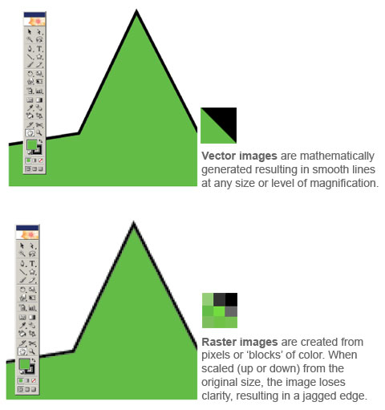

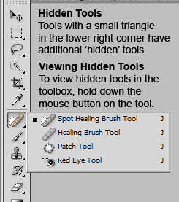
Introduction to the Work Area
The basic Illustrator work area consists of your document window where your artwork is located, a Toolbox that holds Tools for drawing and editing your artwork, and panels to help you modify your artwork. You can rearrange the work area as needed by moving, hiding, and showing panels; zooming in or out of your artwork; or scrolling within the document window. In previous versions of Illustrator, these were also called Palettes.
The following link is a video tutorial on the overview of Illustrator:
Overview of Illustrator: http://www.teachertube.com/view_video.php?viewkey=c551405ff79715374bd0
Panels
Panels are found in the Window drop down menu. They are movable and can be combined, separated, minimized, maximized and closed.
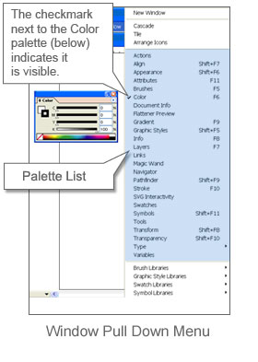
Tools
The Toolbox is simply a special panel within Illustrator. The Toolbox contains drawing and editing Tools, as well as color controls and screen mode buttons. Hidden Tools can be found under Tools with a small triangle in the lower right corner. To view hidden Tools, simply hold down the mouse button on Tool button. This will display all of the hidden Tools under that button where you can then select one of the hidden Tools.
Zooming In / Zooming Out
To zoom in or out of your artwork, there are four different options:
- Use the Zoom Tool in the Toolbox to zoom in. Holding down the Alt or Option key while using the Zoom Tool will allow you to zoom out. (See red arrow)
- Select one of the zoom options from the View menu: View > Zoom In, View > Zoom Out, View > Fit in Window, or View > Actual Size (See blue arrow).
- Use the Zoom Slider or Zoom Buttons on the Navigator panel (See yellow arrow).
- Use the Zoom Field Pop up menu in the lower left corner of screen (See green arrow).
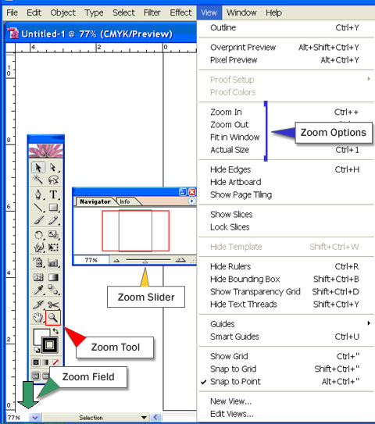

To gain greater precision in how objects are arranged in the work area, Illustrator provides Rulers, Ruler Guides, and Grids. Ruler Guides are straight horizontal or vertical lines created with the ruler. These guides are the simplest to make and are useful for setting alignment lines across the length or width of the work area. The Grid appears as lines or dots behind your artwork, and can be used to arrange objects symmetrically. When dragging an object, the cursor will automatically snap to these guides or grids if the Snap To Point or Snap to Grid options are turned on.
Ruler commands:
- To view or hide rulers, choose View > Show Rulers or View > Hide Rulers.
Guide commands:
- To create a ruler guide, click on one of the rulers and drag the ruler guide into the work area.
- To lock or unlock guides, choose View > Guides > Lock Guides. A check mark indicates that all guides are locked.
- To move a guide, make sure that the guides are unlocked. Select the guide to move with the Selection Tool and drag it to a new location.
- To delete a guide, make sure that the guides are unlocked. Select the guide you want to delete with the Selection Tool, and press Backspace, Del (Windows), or Delete (Mac OS).
- To delete all guides at once, choose View > Guides > Clear Guides.
- To show or hide guides, choose View > Guides > Show Guides or View > Guides > Hide Guides.
- To snap objects to guides, choose View > Snap to Point. A check mark indicates that snapping is turned on. When an object is dragged within 2 pixels of a guide, it will then snap to that guide. The pointer changes from a filled arrowhead to a hollow arrowhead when a snap occurs.
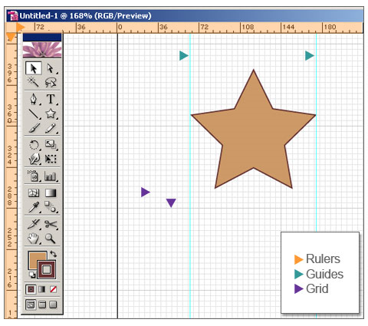

Working with Files
Creating and Opening Files
To create a new document from scratch, select File > New. This will bring up the New Document dialog box, where you can specify settings for the name, size, ruler units, and orientation of the artboard, as well as the color mode for the document. In general, choose CMYK if the artwork will be printed and RGB if the artwork will be for on-screen display. This can be changed by clicking on the Advanced button within the New Document Dialog box.
Tip: The first time you are working with Illustrator, the units will be in points. Change the units to inches by clicking on the dropdown list for Units.
To open an existing file, select File > Open. Locate and select the file you want to open, and click Open. You can also open a file that has recently been used by selecting File > Open Recent Files, and choosing the filename from the list.
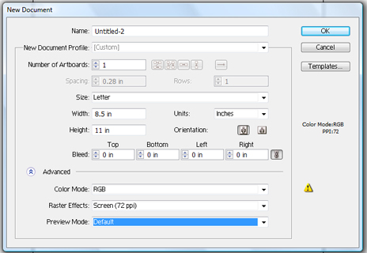
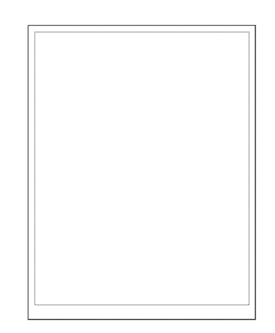
Artboard Size / Page Boundaries
When you create an Illustrator document, the Artboard size you select will be displayed on the screen as an outline. However you are free to work in the entire area on the screen and if you zoom out you can use an even larger work area.
If you are working in RGB for the web, this outline will be the outer dimensions of your image as it appears on screen. However if you are working in CYMK for print, the Artboard dimensions will not match the Print Tiling, which is displayed as a fine dotted line. You can view the Print Tiling in relation to the Artboard by showing Print tiling (View > Show Print Tiling).
The Print Tiling matches the actual area that your printer can print. If your artwork is larger than your printer permits, you can print the artwork in pieces by using the tiling options in the Print dialog box.
Color Modes
Adobe Illustrator allows you to work in one of two Color modes: CMYK or RGB. We generally use CMYK mode for artwork that will be printed and RGB mode for artwork that is solely for on-screen display. You can change the color mode of a document by selecting File > Document Color Mode > and choosing CMYK Color or RGB Color.
Using Undo / Redo
While working in Illustrator, you can use the Undo command (Edit > Undo) to correct any mistakes you may make along the way. Depending on how much memory is available, you can undo an unlimited number of previous operations, in reverse order, by repeatedly choosing the Undo command. If an operation cannot be undone for some reason, the Undo command is dimmed.
You can similarly use the Redo command (Edit > Redo) to reapply operations that you previously undid. You can also revert a file to the version that was last saved by choosing File > Revert. Reverting a file is something that cannot be undone however, so be sure that you no longer want any changes made to the file since the last time it was saved.

Color
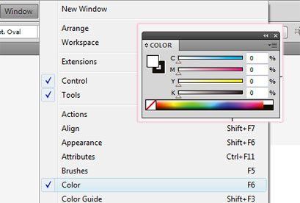
Selecting Colors
Before we can learn how to begin drawing in Adobe Illustrator, we will first learn how to select colors. In both the Toolbox and Color panel, you’ll find two color swatches that overlap one another. One is a solid square, the other is an outline of a square. The solid square indicates the “fill” color, or the color that is inside a selected shape. The outline of a square indicates the “stroke” color, or the color that is outlining the selected shape.
Double-clicking on either of these color swatches in the Toolbox or in the Color panel will bring up the Color Picker, which allows you to choose a color from a color spectrum or to define a color numerically. You can also specify colors directly through the Color panel. If the Color panel is not visible, you can display it by selecting Window > Color.
The Color panel can display color values using different color modes that can be accessed via the popup menu triangle in the upper right hand corner of the panel:
- Grayscale: To choose a grayscale color or convert colors to grayscale.
- RGB: Red-Green-Blue, to mix colors for video or web output.
- HSB: Hue-Saturation-Brightness, to individually adjust fundamental color attributes.
- CMYK: Cyan-Magenta-Yellow-Black, to create process colors for print output.
- Web Safe RGB: to choose colors for Web output.
With a color mode selected, you can then drag a color slider, click a spot along the color bar, or enter a value in the corresponding text box to adjust the color. You will see the effect of changing that property on the other color sliders.
Also, it is important to note the difference between having no color selected for the stroke or fill and having white selected. A white box with a red slash through it indicates having no color selected, while the color white is simply indicated by a white box.

Beginning Drawing
Before objects can be edited in the Illustrator work area, they must first be selected. Illustrator provides two primary Selection Tools for this purpose.
Selection Tool Lets you select objects by clicking or dragging over them.
Direct Selection Tool Lets you select individual anchor points or path segments by clicking on them. If the path is filled, you can click inside the object with the Direct Selection Tool to select all anchor points. You can also select one or more objects in a group of objects.
To select objects with the Selection Tool
- Choose the Selection Tool.
- Do either of the following:
  - Click an object.
  - Drag a marquee around part or all of one or more objects.
- To add or remove objects from the selection, hold down Shift and click or drag around the objects you want to add or remove.
- Click, hold, and drag over multiple objects to select them.
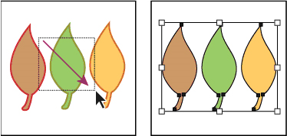
To select a single object within a group:
- Select the Direct Selection Tool , and click within the object, or drag a marquee around part or all of the object’s path.
- To add or remove an object or group to the selection (with any selection tool), hold down Shift and select the object to add or remove.
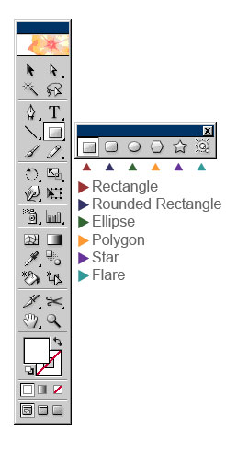
Shape Tools
One of Illustrator’s primary strengths is its ability to draw vector-based lines and shapes. The following shape tools can be found in the Toolbox:
From left to right, these are the Rectangle, Rounded Rectangle, Ellipse, Polygon, Star, and Flare Tools. By clicking and dragging in the work area with one of these tools, you are able to create the designated shape of a desired size and orientation. You can also single-click in the work area with one of these tools to create the designated shape numerically. Doing so will bring up a dialog box where you can specify all of the various attributes for that particular shape. The attributes you specify (apart from dimensions) will then be the same ones applied the next time you create a shape with that tool by clicking and dragging. You can press any of the following keys to get specific results as you drag:
- Shift: To constrain the tool to multiples of 45°, creating squares with the Rectangle Tools and circles with the Ellipse Tool.
- Spacebar: To move a shape as you draw it.
- Alt (Windows) or Option (Mac OS): To draw from the center outward.
- Up Arrow or Down Arrow: To add or delete sides to a polygon or star. To do so, you must be drawing the shape as you press the up arrow or down arrow.

Saving Images
Saving artwork in an application’s native file format will allow you to go back and edit the artwork at a later time. To save artwork in a native Illustrator format, choose File > Save to save changes you’ve made to the current file. Choose File > Save As to save the changes to a different file. When saving changes to a different file or when saving a file for the first time, you will need to enter a filename and choose a location for the file. Selecting Illustrator (.ai) as the file format will keep the file in native Illustrator format for future editing. You can save your file in the following formats: AI, PDF, EPS, AIT, SVG, or SVGZ.
- Saving and Exporting
  - Save Documents
  - Export to Photoshop
  - File Formats
  - PDF
What is an EPS and when do I use it?
EPS stands for Encapsulated PostScript. You can save your file as an EPS when you want to include it in a page layout program such as Adobe InDesign. Logos are often saved as an EPS file because another user, such as professional print shop, cannot alter the file as easily as you would be able to with an AI file. The EPS file essentially acts as a protective box when sending files to another user where you do not want the file to be altered. Professional print shops also prefer this file format for placing images into page layout programs. EPS files should be CMYK since they are used for printing purposes only. You should also always save the native AI file so that you can go back and edit the original file if necessary.
What is a PDF and when do I use it?
PDF stands for Portable Document Format. PDF files can be created from any file from any application and viewed by anyone with Adobe Reader, a free download. PDFs can be used for either high-quality printing or web display by choosing the correct PDF preset. When working with Adobe Illustrator, you should always save the native AI file so that you can go back and edit the original file if necessary.
Save for Web & Devices
In addition to saving your artwork in native Illustrator format, you may also need to export files to other formats, such as JPEG or GIF for web display (or for posting in your online class). This can be accomplished using the Save for Web command. To display the Save for Web dialog box, choose File > Save for Web & Devices. You will notice that the dialog box that appears is the exact same as the dialog that appears when you select the command in Photoshop. There are two additional output formats available to you when you choose “Save for Web & Devices” from Adobe Illustrator:
- SWF: This is the proprietary file format of an Adobe Flash multimedia file.
- SVG: This is a Scalable Vector file format which is an Adobe initiative for vector files on the web.
GIF is the standard web format for images with flat color and crisp detail, such as line art, logos, or illustrations with type. JPEG is the standard web format for continuous-tone images such as photographs. The easiest way to specify all of the various settings for a GIF or JPEG image is to use one of the presets from the Settings pop-up menu. “GIF 128 No Dither” is a good setting for most GIF images and “JPEG High” is a good setting for most JPEG images. Once you have specified the settings for your file, click Save, then enter a file name and choose a location for the file. At the end of the Save for Web process, you will have exported a web-ready image while keeping your native Illustrator file intact.
Keyboard Shortcuts
Keyboard shortcuts allow you to quickly execute commands or select tools within Adobe Illustrator. Each week we will present you with a series of keyboard shortcuts that relate to the week’s material. These shortcuts will allow you to more efficiently complete actions in Illustrator, and over time, should become part of your everyday workflow.
When a choice of CTRL/CMD is given, this means that Windows user should hold down the Control key while Mac users should hold down the Command or Apple key. When a choice of ALT/OPTION is given, this means that Windows user should hold down the Alt key while Mac users should hold down the Option key.
Files
Create New File - CTRL/CMD + N
Open File - CTRL/CMD + O
Close File - CTRL/CMD + W
Save File - CTRL/CMD + S
Save File As – SHIFT + CTRL/CMD + S
Save for Web & Devices – ALT/OPTION + SHIFT + CTRL/CMD + S
Undo - CTRL/CMD + Z
Redo – SHIFT + CTRL/CMD + Z
Viewing
Zoom In - CTRL/CMD and + (plus)
Zoom Out - CTRL/CMD and - (minus)
Fit in Window – Double click Hand Tool, or CTRL/CMD + 0 (zero)
Actual Size – Double click Zoom Tool, or CTRL/CMD + 1
Temporarily Show Hand Tool (with another tool selected) – Press SPACE
Show/Hide Rulers - CTRL/CMD + R
Show/Hide Guides - CTRL/CMD + ; (semi-colon)
Show/Hide Grid - CTRL/CMD + “ (quote)
Tools
Select Selection Tool – Press V
Select Direct Selection Tool – Press A
Select Rectangle Tool – Press M
Select Ellipse Tool – Press L
Select Hand Tool – Press H
Select Zoom Tool – Press Z
Panels
Show/Hide all Panels – Tab key
Show Color Panel – Press F6
Selecting Objects
Select All - CTRL/CMD + A
Deselect – SHIFT + CTRL/CMD + A
Temporarily Show Selection Tool (with another Tool selected) – Press CTRL/CMD
Add to Current Selection – Hold SHIFT key, and then make new selection
Subtract from Current Selection – Hold ALT/OPTION, and then make new selection
Help
Illustrator Help - Press F1

Assignment 1: Creating/Saving Files and Placing Guides
The goal of this exercise is to create a new Illustrator document with specific initial settings, to place ruler guides at specific locations in the document, and to make the grid visible.
Create a new Illustrator document with the following settings:
- Size: 8.5 inches x 11 inches
- Color Mode: RGB
Next, make the Grid and Rulers visible, and place Ruler Guides at 1-inch margins from all 4 sides of the document. Save your document in native IL format. Post your assignments in the Discussion Area, if your file size is too large use the Doc Sharing. Use the Discussion Area to review and comment on other students’ work.
Assignment 1 Review Criteria
Document has correct settings (size and color mode)
Grid and Rulers visible
Ruler guides placed at proper locations
Document saved in proper format

Grids and Guides
Hi All,
You might wonder about why you just made a guide. Here's more information:
"About guides and the grid
Guides and the grid help you position images or elements precisely. Guides appear as nonprinting lines that float over the image. You can move and remove guides.You can also lock them so that you don’t move them by accident.
The grid is useful for laying out elements symmetrically. The grid appears by default as nonprinting lines but can also be displayed as dots."
From our ever helpful Help Menu.
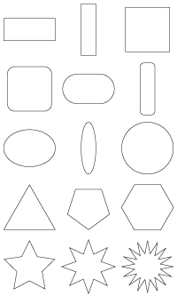
Assignment 2: Beginning Drawing
In this exercise, you will practice using the Shape tools and modifier keys to recreate predefined shapes.
Complete the following steps:
- Download and unzip the template. Two versions of the template have been included in this zip file. Please use the file that more closely matches the version of software that you are using. *Note to Mac users: If the file won't open correctly, please remove the file extension and manually rename it with ".ai" following the filename.
- Set the Fill Color to None, the Stroke Color to Black, and the Stroke Weight to 1pt.
- Trace the 15 provided shapes using the following tools:
Row | Tool | Modifiers
1 | Rectangle Tool | Alt/Option – Draw from center outward  Shift – Create squares  Space – Move shape while drawing
2 | Rounded Rectangle Tool | Alt/Option – Draw from center outward  Shift – Create rounded squares  Arrow Keys – Increase/decrease corner radius  Space – Move shape while drawing
3 | Ellipse Tool | Alt/Option – Draw from center outward  Shift – Create circles  Space – Move shape while drawing
4 | Polygon Tool | Shift – Prevent shape rotation  Arrow Keys – Increase/decrease number of sides  Space – Move shape while drawing
5 | Star Tool | Shift – Prevent shape rotation  Arrow Keys – Increase/decrease number of points  Space – Move shape while drawing

The drawn shapes must align precisely with the template shapes. You are encouraged to place Ruler Guides and use the Grid to assist with alignment.
Save your document in native IL format. Post your assignments in the Discussion Area, if your file size is too large use the Doc Sharing. Use the Discussion Area to review and comment on other students’ work.
Please Note: For those students using Safari you must manually remove the .ps extension when saving the template file.
Assignment 2 Review Criteria
Traced shapes aligned with template
Traced shapes have correct fill and stroke settings
Document saved in proper format

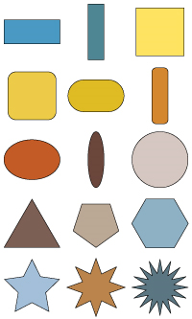
Assignment 3: Color
In this follow-up exercise, you will apply color to the shapes you drew in the previous exercise.
Complete the following steps:
- Open your file submission for W1: Assignment 2.
- Select each shape and give it a unique Fill color.
Save your document in PDF format, using the Smallest File Size preset. Post your assignments in the Discussion Area, if your file size is too large use the Doc Sharing. Use the Discussion Area to review and comment on other students’ work.
Assignment 3 Review Criteria
Each shape given a unique Fill color
Document saved in proper format

